

***A Frenetic First-Person Shooter (FFPS)***

**Game Design Document**

Version 2.0

Produced by Dylan Blereau, Bryce Standley, and Christopher Logan

Created: February 26, 2021

Updated: May 28, 2021

Table of Contents



Contents

Game Overview 4

Philosophy 4

Philosophical point #1 4

Philosophical point #2 4

Philosophical point #3 4

Common Questions 4

What is the game? 4

Why create this game? 4

Where does the game take place? 4

What do I control? 5

How many characters do I control? 5

Who is the target demographic? 5

What is the main focus? 5

What’s different? 5

Feature Set 6

General Features 6

Implemented Features 6

Not Yet Implemented Features 6

Editor 6

Gameplay 6

The Game World 8

Overview 8

Key Locations 8

Travel 8

Scale 8

Objects 8

Weather 8

Day and Night 8

Time 8

Rendering System 8

Overview 8

2D/3D Rendering 9

Camera 9

Overview 9

Camera Detail #1 9

Camera Detail #2 9

Game Engine 9

Overview 9

Game Engine Detail #1 9

Water 9

Collision Detection 9

Lighting Models 9

The World Layout 11

Overview 11

World Layout Detail #1 – Randomly placed enemies 11

World Layout Detail #2 – Randomly placed furnishings 11

Game Characters 12

Overview 12

Creating a Character 12

Enemies and Monsters 12

User Interface 13

Main Menu Screen 13

Results Screen 13

Credits Screen 14

Controls Screen 15

Weapons 16

Overview 16

Weapons Details #1 16

Sound and Music 17

Overview 17

Sound Effects 17

Music 17

Single-Player Game 18

Story 18

Core Gameplay 18

Modes of Play 18

Attack Waves 18

Quick Rest 19

Scoring 19

Killing a Demon 19

Clearing a Wave 19

Collecting a Power-Up Token 19

Game Flow 19

Splash Screen 19

Main Menu Mode 20

Play Mode 20

Results Screen Mode 20

Credits Screen Mode 20

Power-Ups! 20

Gameplay Length 21

Victory Conditions 21

AI Features 21

World Editing 22

Overview 22

World Editing Detail #1 – Customisable Terrain! 22

World Editing Detail #2 – Customisable Skybox! 22

World Editing Detail #3 – Customisable Object Placement! 22

Extra Miscellaneous Stuff 23

Overview 23

Junk I am working on… 23

Bounding Boxes 23

# Game Overview

## Philosophy

### Philosophical point #1

We aren’t intending for ZOOM to be the greatest game of all time, but we are hoping that the quality of our engine will see it received as a solid and enjoyable experience.

### Philosophical point #2

We believe that our game should run on pretty much any computer with a graphics card. We don’t need crazy stylish graphics to the get the point of our game across, and we want as many people to give it a try as possible.

### Philosophical point #3

We want to craft a game we are proud of as a team, with the final game to be the resultant product of each team members ideas. While one person may come up with the core ideas, each team members ideas will be considered and applied if the idea is well received.

## Common Questions

### What is the game?

ZOOM is a quick and addictive FPS that transports gamers back to early days of first-person shooters. It is heavily inspired by some of the first-person shooter genres most prominent games such as DOOM and QUAKE, with a little sprinkle of influence also coming from the Call of Duty franchises Zombies mode.

ZOOM seeks to take the fast-frantic FPS gameplay seen in DOOM and QUAKE and combine it with the gameplay loop of Call of Duty Zombies, ultimately creating an engaging and intense gameplay experience.

### Why creates this game?

We wanted to create ZOOM as it was the amalgamation of all the games we love to play. First-Person Shooters are a genre we all have played through our formative years and we felt like making a game that cherry picked the elements from the games we liked would result in a game that is both fun to develop and play.

As a team, we also each had prior experience creating a game in the first-person perspective, which was another reason as to why we picked a first-person shooter.

### Where does the game take place?

ZOOM takes place on a small but dangerous moon that has mysteriously appeared in the solar system, not too far from the Earth’s moon. The people of Earth grow increasingly anxious and suspicious of this new moon, but they continue to live out their everyday lives. A few days after the moon’s arrival, Demon’s start appearing around the globe, attacking civilians, and claiming Earth as property of the underworld. In retaliation to the attack on Earth by the Demons, the United Nations enlist the help of ZOOM Girl, a biological superhuman who they see as humanity’s only hope of eradicating the demonic spawn. ZOOM Girl is quickly sent to the Demon moon now known as the “Neighbour in the Night Sky” with a simple mission – kill as many Demons as you possibly can.

The “Neighbour in the Night Sky” moon is the only area in ZOOM.

### What do I control?

ZOOM Girl is the protagonist of ZOOM. She is heavily inspired by the DOOM Guy from the DOOM franchise and is a tall and athletic woman that wears a giant metal suit. Because the game is from the first-person perspective of ZOOM Girl, you never actually physically get to see her, but the idea and look of the character is implied through the narrative.

### How many characters do I control?

In ZOOM you only control ZOOM Girl. There are no plans for any further playable characters.

### Who is the target demographic?

ZOOM is targeted towards gamers that enjoy fast and fluid movement and shooting in their first-person shooters. The gameplay will be what takes centre stage in this experience, but the graphics are no slouch either with its stylish low-poly aesthetic. ZOOM is a game for anyone that has enjoyed an FPS.

### What is the focus?

The focus in ZOOM is simple. Kill as many Demons as you possibly can until you die. ZOOM Girl is equipped with a trusty shotgun that can turn any Demon in her path into minced meat, so the key to success in ZOOM is to use the epic weapon to kill as much hell spawn as you come, with the Demons chasing you around in their attempts to kill you.

### What’s different?

Our game isn’t exactly too different from what currently exists on the market, as the game is clearly inspired by multiple titles that have graced the gaming sphere over recent years.

What does make ZOOM different though is the fact that the game takes ideas from various games and bundles them all into one solid experience. We feel that ZOOM is a successful combination of its inspirators, providing an overall experience that is new but familiar at the same time.

# Feature Set

## General Features - Dylan

Big outdoor world

Multitextured Terrain complete with a detail map and lighting

3D graphics

Stylish Skybox

Quality First-Person Shooter Gameplay

Randomly placed enemies and environment features (currently spawning 20)

Collision Detection with terrain and environment obstacles

Ability to pick up power-ups and kill demons by colliding with them (Gun will be incorporated into assignment 2 which will be used to kill the demons)

Fully Animated Enemies with Artificial Intelligence

## Implemented Features - Dylan

**Required Features**

Terrain exceeding 3km squared

Terrain has multitexturing, a detail map, lighting

A reasonable number of obstructions (rocks and trees)

Skybox

Water Feature (Serves as the area in which the player can be killed)

No visible end of world

Visible bullets

20 Demon NPCs spawn on the map

NPCs communicate with each other (If an enemy sees the player it calls for assistance from enemies within a certain distance)

Main Character and Demons follow the terrain and detect collisions

NPCs are animated via animation engine and animations are synchronized with its AI state in a Finite State Machine

NPCs exhibit intelligent behaviour (Chase, Flee, Wander, Alert)

Menu UI with options such as new game, load game, exit etc

On screen displays for Health, Points, number of kills etc

Redisplay of options menu upon game completion

Ability to save game state and load in the save

First-person character walks along terrain and follows the ground level.

Mouse controls allows the first-person camera perspective to look around

**Bonus Mark Features**

Various difficulty options (Easy, Medium, Hard)

In summary, everything that needed to be implemented is present in the final build of ZOOM.

## Not Yet Implemented Features

We implemented all features that were required, however we never got to implement the wave-based gameplay vision we had for ZOOM. There are also a few power up tokens that are listed in the Power Ups! section of the document below that never made the final cut. Lastly, we never implemented

## Editor

While there is no traditional level editor available with TNAH (Team Names Are Hard) Engine, the engine allows for customization through lua scripts.

From using your own heightmaps to picking how many enemies/power ups/environment obstacles that you want to spawn and position on the map, the onus is on the player to customize the experience to their liking if they want to do so.

The controls, skybox, enemy AI and Menus can even be changed if the user wants via their respective scripts.

Even though there is no explicit level editor, the TNAH engine does provide users an easy and effective way to put their own spin on the game.

## Gameplay

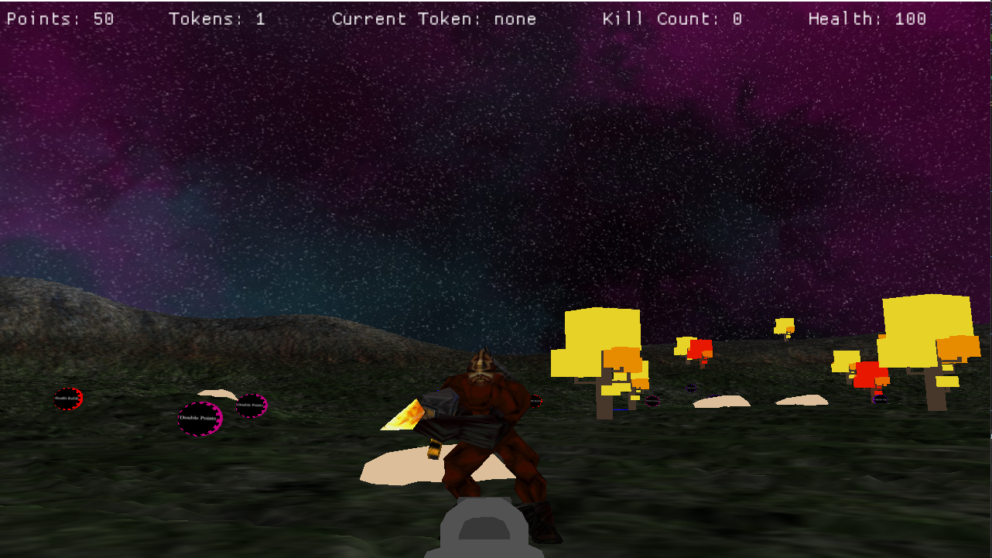

ZOOM is a frenetic first-person shooter inspired heavily by FPS juggernauts DOOM and Quake, as well arcade games such as Pac-Man, where setting as high a score as possible is the ultimate goal.

In ZOOM, your mission is a simple one. Your task is to kill any foe that gets in your way, accruing as many points as you possibly can before dying. Killing an enemy will take a few blows from your trusty infinite ammo shotgun but be aware that the Demon spawn that roam the moon have powerful weaponry of their own.

How tough these enemies are exactly will be determined by the difficulty option you selected when starting the game. There are three options to choose from – Easy, Medium, Hard. The higher the difficulty selected the greater the overall health, damage output, and view distance will be for each enemy.

Shooting an enemy is as ensuring you are within range of your enemy, pointing your weapon at them and pressing the left mouse button down to unleash a shotgun blast. You can only take so many hits yourself, so be mindful of your overall health as dying means that your run is finished. Each enemy you kill will respawn another, so you will need to be quick on your toes if you want to last long and build up an enviable point score.

Points which serve to highlight your overall score throughout a ZOOM play session can be earned by killing enemies and collecting the upgrade tokens that are present throughout the map. Tokens grant abilities such as a temporary movement speed upgrade, double points, double damage, and even a health refill that will fully replenish your health upon collection.

The key to success in ZOOM is to constantly be moving around the map, picking off enemies as they attack you and collecting tokens when they are best suited to the situation, such as collecting a health refill when your health is really low, or collecting double points in a moment where you can easily kill a multitude of enemies before the token expires.

# The Game World

## Overview

The game world of ZOOM takes place on the mysterious moon known as the “Neighbour in the Night Sky”. It is a relatively small moon that houses hellish demons.

### Key Locations

The key location of ZOOM is the “Neighbour in the Night Sky” moon. It is the only place of interest in ZOOM.

### Travel

The protagonist ZOOM Girl makes her way across the map zooming at a quick pace.

### Scale

The scale of ZOOM is largely meant to mimic real life. ZOOM Girl is a similar size to the demons as seen by the first-person perspective, while the moon features trees and rocks that are scaled to a size that could be seen in real life.

### Objects

The following objects make up the world of ZOOM.

* Trees
* Rocks
* Power-Up Tokens
* Demons
* Water Feature

### Weather

There is currently no form of weather system in ZOOM.

### Day and Night

There is no day and night cycle in ZOOM. The game is seen to occur at night on the “Neighbour in the Night Sky” moon.

### Time

Time is measured when timed upgrade tokens such as doublePoints, doubleDamage, and speedup are collected, ensuring they expire when the timer runs out. Other than that, time isn’t required in ZOOM.

## Rendering System

### Overview

Our game is rendered in 3D using OpenGL. The game utilizes OpenGL to set data gathered from outside files, such as fbx, md2, heightmap files and image files setting them into memory so they can be called and displayed to the user. The rendering system allows for many different models to easily be loaded into the game and shown to the user and allows for many to be displayed at once on reasonable hardware.

### Terrain

The rendering system allows for it to take in information for a terrain from a height map, and then output it to the user. It takes in the data from the height map outside the renderer, but when passed into the renderer, it will load all of that information, being its positions, lighting points, texture points, textures and shaders, putting them into memory for use. It will then be called during the world ,and render, showing the layered textures, and lighting.

### Skybox

The renderer creates a large box around the games space, taking in the textures and outputting them onto the walls surrounding them, building up the world’s environment.

### Models

The renderer allows for models to be loaded in and then stored into memory for output. Each model has textures and meshes, with the renderer taking the information gathered within the engine for the models, meshes, textures and shaders, to the use them, setting it into memory. Then when called the meshes will be shown to the users in 3D, with a texture on. These models are using fbx model files, with png texture files.

## Camera

### Overview

The camera holds the information that allows the player to see the game world. It holds information such as position, forward, pitch and yaw. This information is then manipulated to give the player the viewing experience they are getting. The camera is in first person view for the player, as we will have first person shooting mechanics later on. The speed of the movement and camera is in line with our game, as it is meant to be a fast-paced game.

### Keyboard Movement

The camera is in bound to keyboard movement for front, back, left, right movement. Using a script, you can set which key binds to which one of these which will then allow the player to move around. The movement is relatively fast to go with our game, it moves the camera position in the direction you are clicking. Forward moves you forward, back moves you back, left moves you left and right move you right, and the actual direction of the camera never changes, as these positions are relative to that and change depending on what way you are viewing.

### Mouse Movement

The camera can move around using your mouse. The camera uses the size of the screen, pitch, and yaw to position the cursor at the center of the screen and uses that to get the viewing of the player. You can go 360 degrees on the x axis and roughly 180 on the Y axis, starting from your feet to your head. This also dictates the forward position used by the keyboard movement.

## Game Engine

### 

### Overview

The game engine handles every aspect of the game, with the main 3 being the worlds, window, and manipulations. The engine runs of code created using glfw, glad, Assimp, glm and other libraries. It allows for scripts to be read that provide it with information in terms of where to put game objects, the window size, inputs, and the number of worlds. The engine is then able to take in fbx models with textures, generate terrains from height maps or apply skyboxes. It allows all the information required to set these things up and maintain them.

### Façade

The game engine will check if different components are available to you and use them if they are. There are 2 main examples of this in our engine, the renderer, and the window. Each of these are parent classes that have abstract children OpenGL and GlfwWindow. The engine allows it so that if you want to you another API such as Vulkan, it would be implemented using Vulkan as the child class which holds the functionality.

### World

The game uses a world class as the primary way of holding its information. Each world holds GameObjects, terrain and a skybox, and uses scripts to manipulate these. The world class also provides the function to update the game objects and the world itself, and then also call the render functions on the game objects so that can be rendered within the world. This class was previously called scene but was change as world was a more suited name.

### GameObjects

The game engine allows for multiple models to easily be inserted into a world with a script. It the world scripts use the makeGameObject function, that takes in variables such as file path, shader path, size, and position, and can place the given objects where you decide, and they also have collision detection. There are different types of game objects as well, such as static, enemy and tokens.

### Collision Detection

Collision detection uses a simple sphere collider to determine if the player or enemy object is in collision with a static object. This is controlled by checking if the player or enemy is within a set distance to a given object and either stopping the movement or forcing the movement to either side of the collided object. Terrain collisions are checked by keeping the player a set distance above the terrain at any point. The player can’t move further in or away from the terrain due to this collision system. Collisions are also used to trigger other game logic like picking up a token for abilities or hurting the player if they walk too far into the water.

### Texture Manager

The texture manager is used to load in textures for the different objects being rendered in the world, such as the skybox, models and terrain. The textures are loaded in and bound using the manager, so that when it is needed for rendering, you would use the textureId gathered from the manager.

### Animations

The animations used is key frame MD2 animations. This is essentially multiple versions of the model in different positions, using frames and frame rates to swap to these and show animation. The frames for which an animation occurs is given, and then the speed or frame rate is also given, which is then rendered and shown, giving it animation. The frame rate effects the speed at which is goes, as an example the walk animation is a slowed down run, as the frame rate given is lower. Such animations are used for both the Enemy and player gun models.

### AI

The AI is state driven AI, with each state providing functionality and circumstances for it to change to another state. It is used to provide the game objects functionality, in our case with the enemies. They each have a Finite State Machine, having states for attacking, wandering, fleeing, chasing, alerting and dying. The AIs states are using functions defined in lua, allowing them to be easily edited for the game via their scripts.

## Lighting Models

The lighting used on the terrain in ZOOM makes use of the phong lighting model. The phong lighting model is created by combining three forms of lighting known as ambient lighting, diffuse lighting, and specular lighting.

Ambient lighting is a simple global illumination technique that provides a small but constant light colour despite their not being a direct light source. It essentially makes it look like there is always some light on objects. Ambient lighting is achieved by multiplying the colour of a given light source by a small value that represents the strength of the ambient light. This is then multiplied in the fragment shader by the objects colour, resulting in some basic but visible lighting.

Diffuse lighting represents the direction impact that light source has on an object. Diffuse lighting works as you’d expecting lighting to work, with the parts of the object that are being hit by the light source illuminated more than others. This results in more realistic and varied lighting and can be perceived as providing shadows. Diffuse lighting is calculated by getting the dot product between the normal and light direction vectors and multiplying it by the colour of the light source. You can then add the diffuse value to the ambient value and multiply it by the colour of the object again to have ambient and diffuse lighting.

Specular lighting simulates the bright spot of lighting you’d expect to see on shiny objects. Because terrain isn’t expected to be shiny it doesn’t really play as much of a role in our lighting. It is calculated by calculating the dot product between the view and reflection direction vectors and provides a shininess value that will determine large the shiny highlight appears. It is then added to the values of the ambient and diffuse lighting and multiplied by the object colour, providing the resultant lighting.

It's a relatively simple technique, but it provides a level of lighting that looks impressive.

# The World Layout

## Overview

The world layout of the map in ZOOM is different every time you launch it due to the random placement of enemies, tokens, and other environmental obstacles like trees, rocks etc.

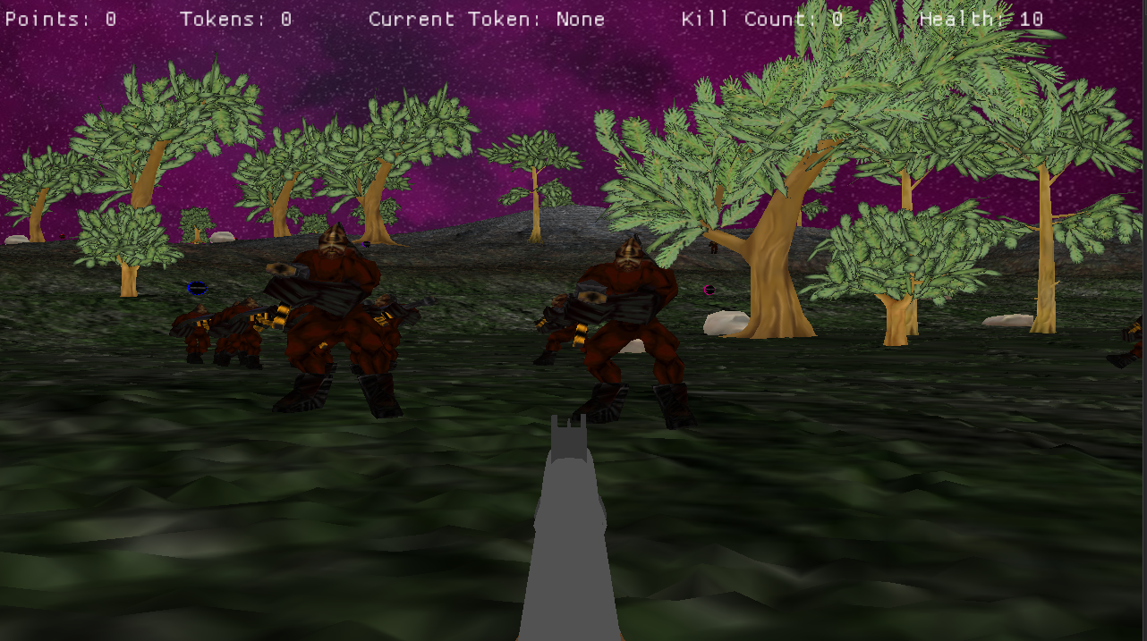

## World Layout Detail #1 – Randomly placed enemies

In the Assignment 2 submitted build of the game, 20 demon enemies are placed on the map at random positions between two values denoted in the world1.lua script. While they aren’t free to spawn anywhere on the map (they could be if we decided to do so simply by editing the script), the fact that their positions change up slightly means that the early stages of a game will be slightly different each time.

## World Layout Detail #2 – Randomly placed furnishings

In the final build of the game, numerous trees, tokens, and rocks are placed on the map at random positions between two values denoted in the world1.lua script. While they aren’t free to spawn anywhere on the map (they could be if we decided to do so simply by editing the script), the fact that their positions change up leads to game feeling a bit more varied and therefore less stale.

## World Layout Detail #3 – Water Feature

ZOOM has a water feature that is placed in the map to mimic a pool of water. It serves as an that ZOOM Girl must avoid throughout the game as if she touches the water her suit will malfunction causing her to die immediately. Enemies aren’t worried about the water feature at all and will happily walk through it with no issue. While the water feature is simply there to satisfy the requirements of the assignment, it does serve as a hazard that ZOOM Girl must avoid.

## World Layout Detail #4 – No visible ending of world

The map used in ZOOM does not display a visible ending of the world. This is achieved by raising the height of the terrain on the edges of the map to the point where enemies and the player can’t walk over it. Taking this approach ensures that we don’t break immersion with invisible walls or a visible end of map.

# Game Characters

## Overview

When it comes to characters the only one’s present are ZOOM Girl and the horde of Demons from the “Neighbour in the Night Sky” moon.

ZOOM Girl is a silent protagonist who you never get to see because of the first-person camera, but we feel that the story characterizes her nicely as this badass female super soldier.

The Demons appear to try and kill ZOOM Girl, but they are unnamed villains and don’t have any personalities. They are described in the narrative as hellish beasts that have come to claim Earth as property of the underworld.

## Creating a Character

Again, as mentioned a few times already, our character does have a back story that serves as the reason as to why the events of the ZOOM video game is occurring, but other than that we haven’t put a great deal of character building into her due to that not being a necessity of the assignment.

## Enemies and Monsters

This is how the Demon characters appear in game:

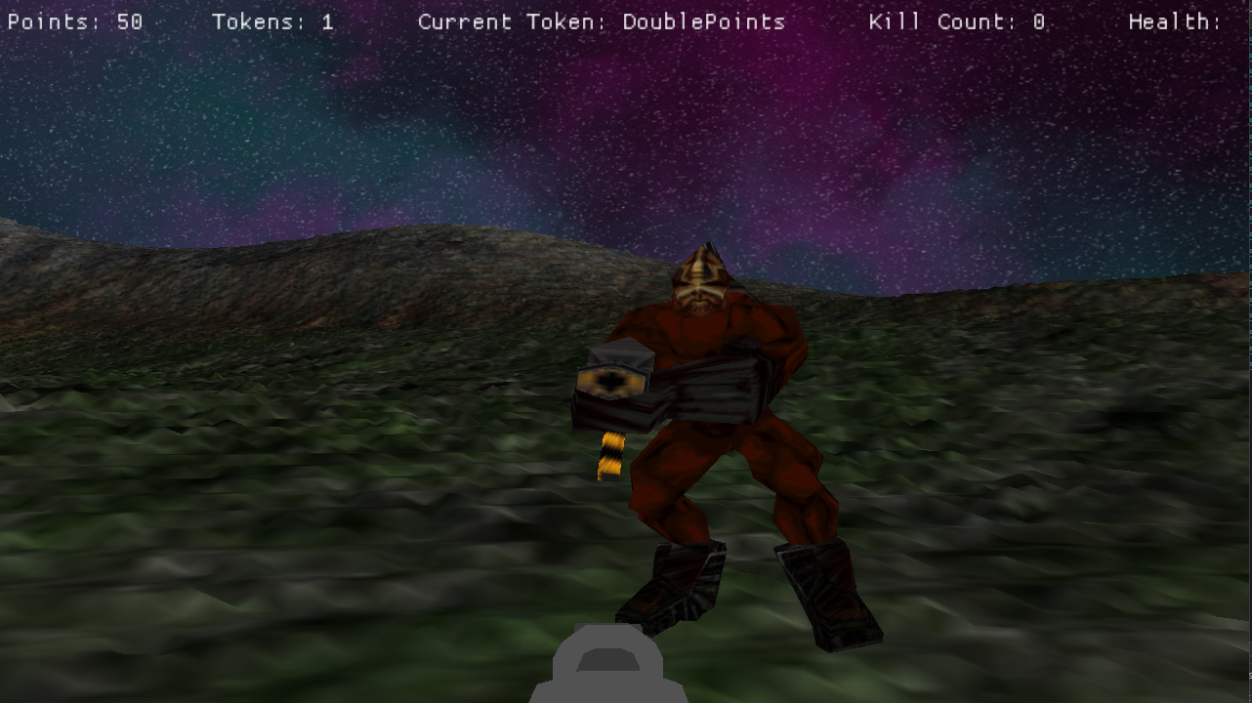

# User Interface

## Main Menu Screen

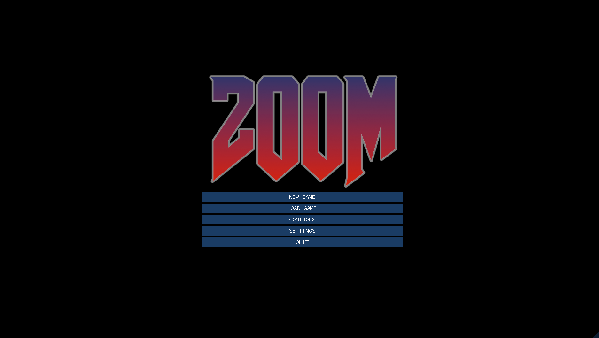

The Main Menu displays the ZOOM logo and the following menu options:

**New Game** – Sends you to the difficulty menu which needs to be selected to create a new games session

**Load Game** – Loads a save file that has been made in a prior play session

**Controls** – Displays all the controls required to play ZOOM

**Settings** – Display some additional settings that the user may want to tweak

**Quit** – Displays the exit screen image of the TNAH development team which when clicked on will close the application

## Controls Screen

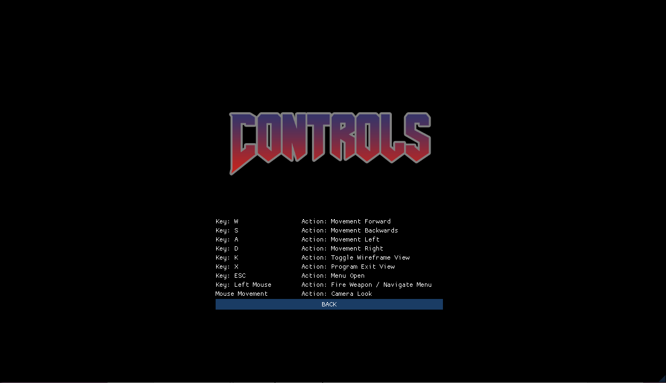

The controls page can be accessed from the main menu and displays the controls required to play ZOOM.

**Back** – Returns back to the previous menu

## Settings Screen

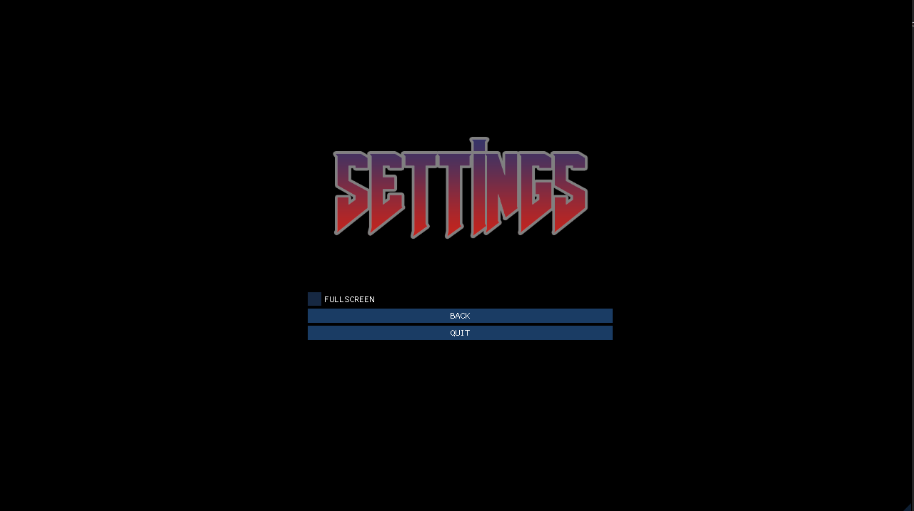

The settings page can be accessed from the main menu and displays additional settings such as a full screen toggle.

**Back** – Returns back to the previous menu

**Quit** – Transitions to the Credits Screen which can then be clicked to exit the game

## Difficulty Options Screen

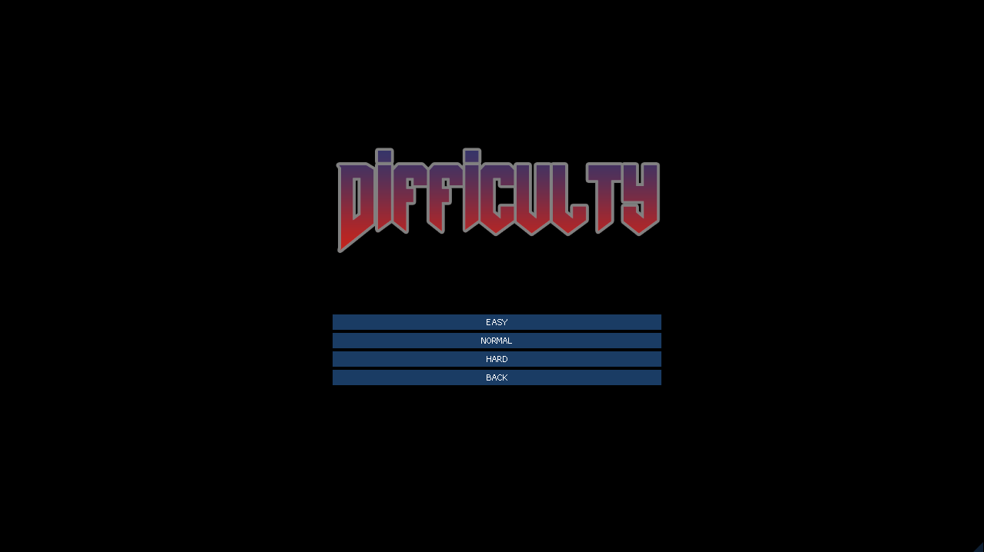

The Difficulty Options Menu provides the following options:

**Easy** – Launches ZOOM with difficulty set to Easy

**Medium** – Launches ZOOM with difficulty set to Medium

**Hard** – Launches ZOOM with difficulty set to Hard

**Back** – Returns you back to the Main Menu

## Results Screen

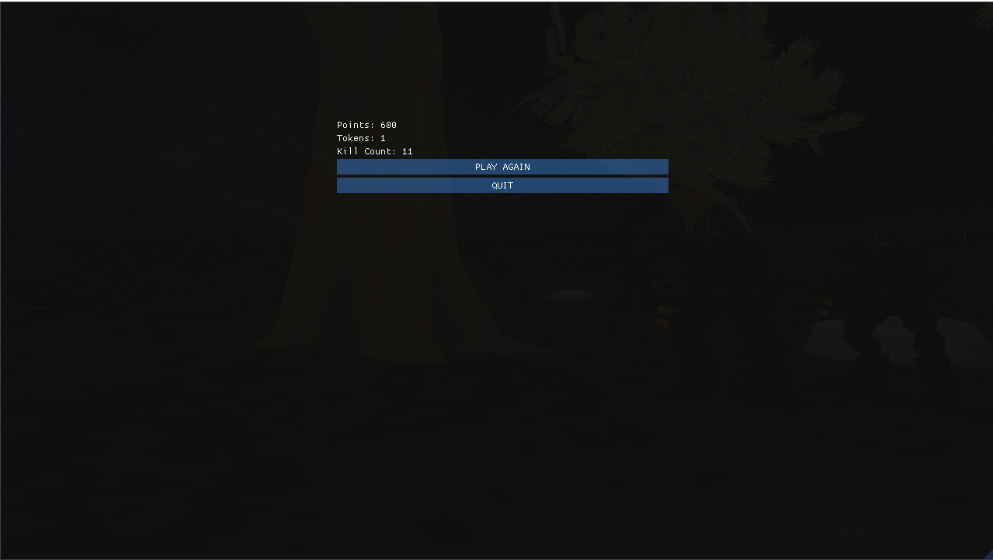

The results page appears when ZOOM Girl runs out of health. It displays the results of the gameplay session, highlighting the total points score, the amount of tokens collected and the amount of demons killed.

**Play Again** – This button will start a new game of ZOOM

**Quit** – Transitions to the Credits Screen which can then be clicked to exit the game

## Pause Menu Screen

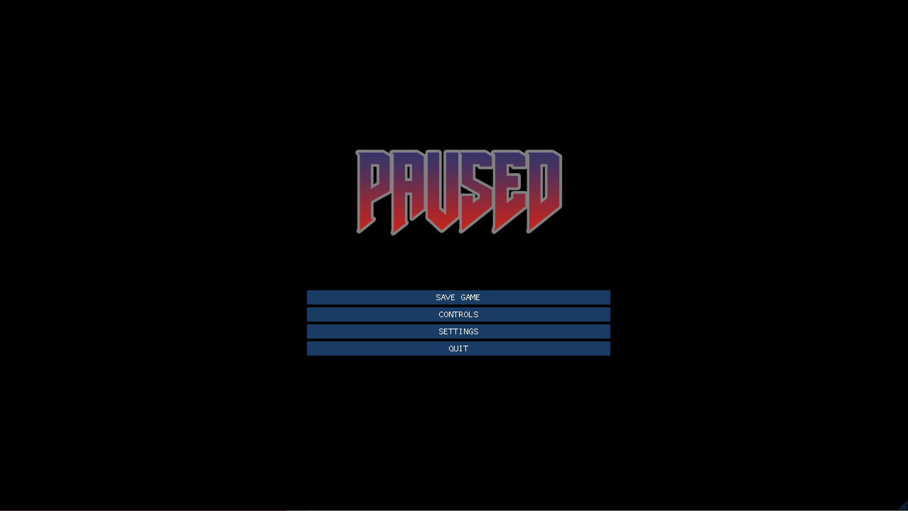

The Pause Menu provides the following options:

**Save Game** – Saves the progress of the current ZOOM gameplay session

**Controls** – Displays the Controls Menu Screen

**Settings** – Displays the Settings Menu Screen

**Quit** – Transitions to the Credits Screen which can then be clicked to exit the game

## In-Game Overlay



The in-game user interface contains all the information relevant to the player while playing through ZOOM.

**Points –** The points value is the total amount of points gathered

**Tokens** – Highlights the number of tokens that have been collected

**Current Token** – Specifies the name of the currently used token (displays “None” if no token is active)

**Kill Count** – Displays the number of enemies killed

**Health** – Displays the amount of health you currently have

## Credits Screen

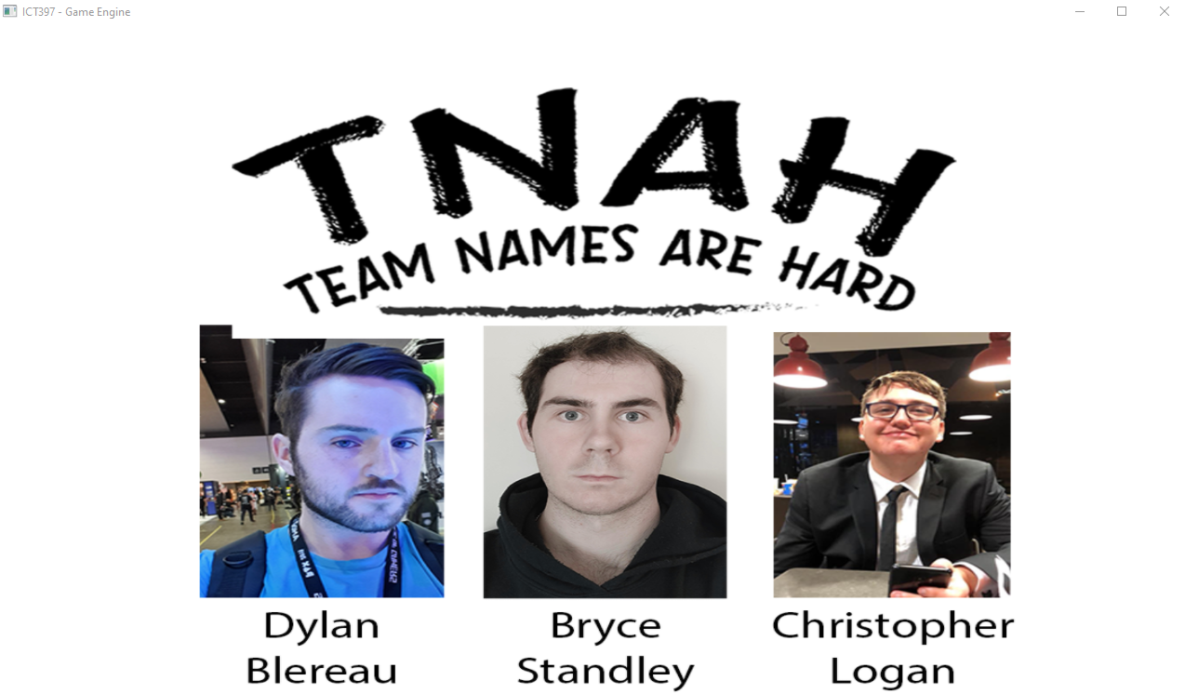

The credits screen will display when exiting out of the game. It will display the faces and names of each member of the development team. A left click on this page will close the application.

# Weapons

## Overview

Overview of weapons used in game.

## Weapons Details #1 – Zoom Girl’s Shotgun

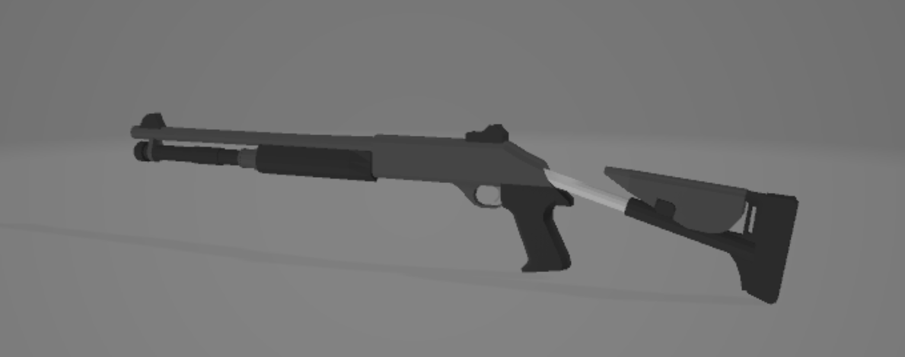

The players weapon (shotgun) is placed as a player model and positioned to be a fixed position in the players view. This is how the model looks in general.

## Weapons Details #2 – First Person View of Shotgun

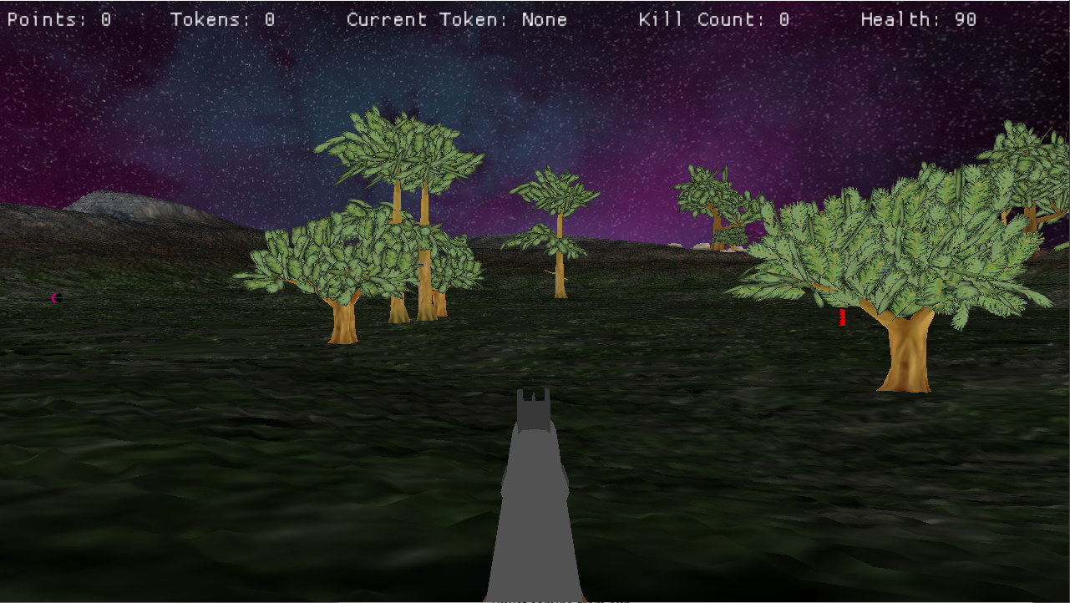

This is how the gun looks in the first-person perspective in ZOOM.

## Weapons Details #3 – Animated Gun and Visible Bullets

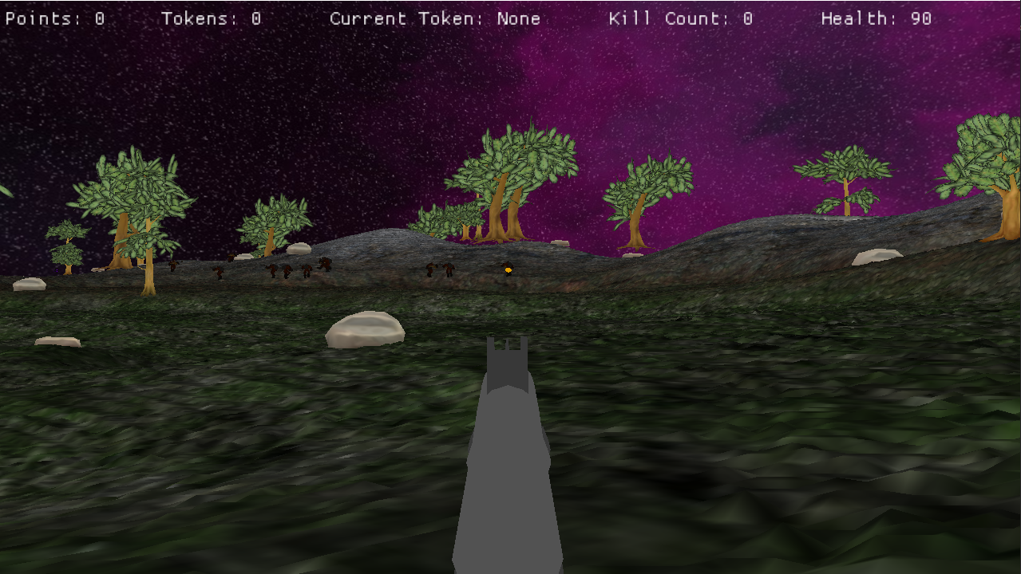

Physical bullets are shot from the gun and an animation plays to show that the gun is being used. The bullets are little yellow spheres which can be seen in the image above.

# Sound and Music

## Overview

The music and sounds for ZOOM should aid in creating an epic and bombastic atmosphere. Like its inspirator DOOM, ZOOM will feature and industrial tech metal soundtrack, with accompanying sound effects for the game’s weapon, power-ups, and demons.

Although we aimed to add a soundtrack and sound effects into the game, due to time constraints and the sound and music not being a requirement of the assignment, they were ultimately not implemented.

## Sound Effects

* Demon noises
* Gun sounds
* Reload sound
* Collected Token
* Player footsteps

## Music

* Main Menu
* Level music
* End of game music

# Single-Player Game

## Story

ZOOM takes place on a small but dangerous moon that has mysteriously appeared in the solar system, not too far from the Earth’s moon. The people of Earth grow increasingly anxious and suspicious of this new moon, but they continue to live out their everyday lives. A few days after the moon’s arrival, Demon’s start appearing around the globe, attacking civilians, and claiming Earth as property of the underworld. In retaliation to the attack on Earth by the Demons, the United Nations enlist the help of ZOOM Girl, a biological superhuman who they see as humanity’s only hope of eradicating the demonic spawn. ZOOM Girl is quickly sent to the Demon moon now known as the “Neighbour in the Night Sky” with a simple mission – kill as many Demons as you possibly can.

## Core Gameplay

The core gameplay of ZOOM consists of the protagonist ZOOM Girl running and gunning around the map, killing endless hordes of demons as they constantly spawn around the map. A greater summary of the gameplay experience can be seen below in “Modes of Play”.

## Modes of Play

### Attack the Demons

When it comes to the gameplay of ZOOM, you’ll quickly come to learn of how simple yet enjoyable it is. As ZOOM Girl your job is to run around the sizeable map killing all demons who get in your way.

The Demon will chase down and attack ZOOM Girl, with more enemies spawning each time an enemy is killed. With her trusty shotgun and the assistance of handy power-ups such as double damage and infinite ammo, ZOOM Girl’s mission is clear, get through as Demons as you can before you are too injured to continue. In layman’s terms, once ZOOM Girl’s health bar reaches zero, the game session ends.

Your current score, health, token count and kill count will be displayed on the screen during each run, giving ZOOM Girl enough intel about how things are tracking.

Power-up tokens are handy timed upgrades that grant ZOOM Girl with abilities such as double damage or double points (see the Scoring section below regarding the Points System). These tokens appear in random positions and don’t respawn after use, meaning you will have to use them wisely (see Power-Ups! Section for further information on Power-ups).

## Scoring

When it comes to scoring, points can be accrued by doing the following:

1. Killing a Demon – 50 Points
2. Collecting a power-up token – 50 Points

Collecting a Double Points Token will double the amount of points earnt for killing a demon for the duration of the token’s life.

### Collecting a Power-Up Token

Grabbing a Power-Up Token will provide the same amount of points no matter what round they are acquired in. They will also provide an upgrade dependent on which token is collected.

**Double Damage** – Rewards 50 points and doubles damage output for the duration of the token

**Double Points** – Rewards 50 points and double points earnt from enemy kills for the duration of the token

**Speed Up** – Adds a 2x multiplier to speed for the duration of the token

**Health Refill** – Fully heals the player upon collection

## Game Flow

The main game flow to be expected in a session of ZOOM is the following:

MAIN MENU à DIFFICULY OPTIONS SCREEN à PLAY à RESULTS SCREEN à CREDITS SCREEN

### Main Menu Mode

Before launching into the gameplay experience of ZOOM, you will first be taken to the main menu. This basic interface provides the option to start a new game or load a pre-existing one from a save file. It also allows you to do things such as view the games controls, tinker with the game’s settings, as well as quit the game application.

### Play Mode

This is the main gameplay mode, as described in the Core Gameplay and Modes of Play sections above.

When the player health reaches 0, the game will transition to the Results Screen.

### Results Screen Mode

When ZOOM Girl finally falls to her demon enemies and her health bar depletes to zero, you will be shown the results screen, which highlights your overall score, as well as how many demons you killed.

### Credits Screen Mode

Exiting out of the game by pressing X will move you to the credits screen. It displays the faces and names development team (as per assignment requirements).

## Power-Ups!

Upon starting a game of ZOOM, various tokens will be present on the map. Collecting one will grant ZOOM Girl a handy upgrade such as double damage output from her trusty shotgun, or a short-timed speed boost that will make it easier to run around the map and eviscerate the demon foe.

|  |  |
| --- | --- |
|  | **Double Damage Token**  When collected, the double damage token will give ZOOM Girl double damage output with her shotgun for 30 seconds. |
|  | **Ammo Refill Token** *This Token was not implemented in the final build*  When collected, the ammo refill token will fully replenish shotgun ammunition. |
|  | **Speed Up! Token**  Zoom Girl already moves fast but collecting a speed up token will add a 2x multiplier to her speed for 30 seconds. |
|  | **Health Refill Token**  When collected, the health refill token will fully replenish ZOOM Girl’s health meter. |
|  | **Free Hit Token** - *This Token was not implemented in the final build*  When collected, this token will end the current wave, eliminating all remaining Demons in the process. |
|  | **Double Points Token** (Allows for the user to earn double points for 30 seconds)  When collected, the double points token will see double points earnt for killing Demons, finishing a wave or grabbing additional tokens for a period of 30 seconds. |

Power Up Tokens and the abilities they grant are managed by the player FSM, a finite state machine that manages the player and places them in different states dependent on what token they have.

Below is a photo of the Player FSM, as well as a summary of each state:

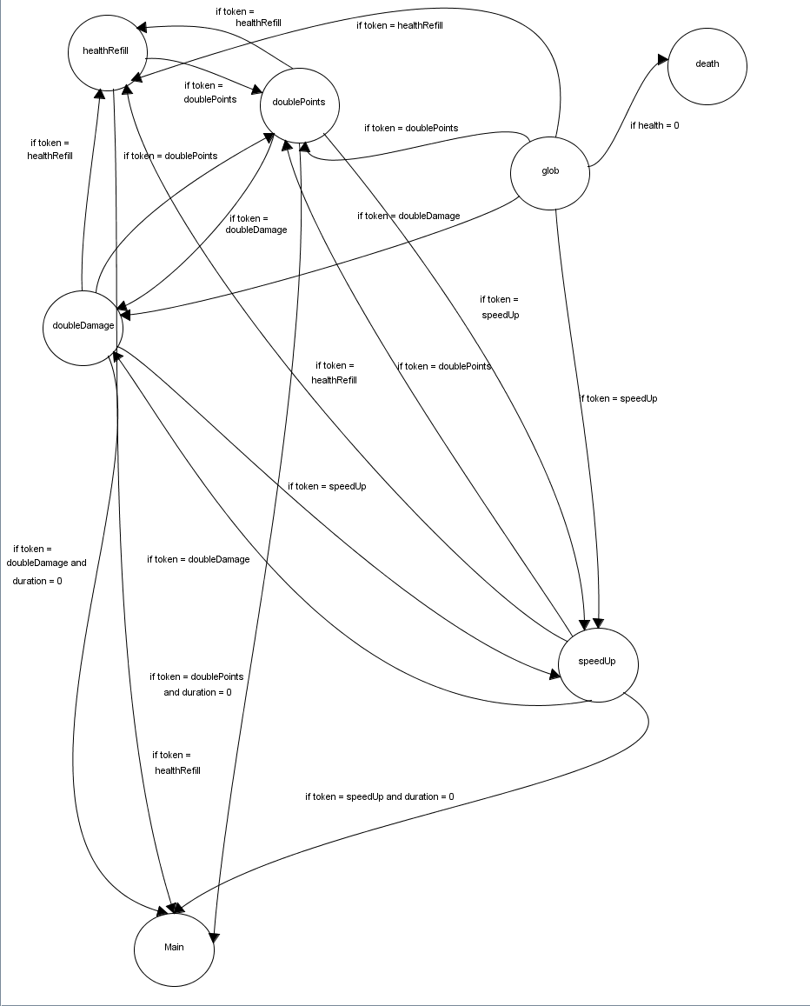

### Main State

The **Main State** is the state that the player is in when not in the token. In this state the player is likely just exploring the environment or shooting enemies. Upon collection of any token type, the main state will transition to the global state (glob), where the global state will then move to the state that matches the token collected.

If the player health reaches 0 in this state, it will transition to the **Death State** and the results screen will display.

### Glob State (Global State)

The **Global State** is the state the player will transition to if they have collected a token from the **Main State**.

If the player has the Speed Up Token the FSM will transition to the **SpeedUp State**.

If the player has the Double Points Token the FSM will transition to the **DoublePoints State**.

If the player has the Health Refill Token the FSM will transition to the **HealthRefill State**.

If the player has the Double Damage Token the FSM will transition to the **DoubleDamage State**.

If the player health reaches 0 in this state, it will transition to the **Death State** and the results screen will display.

### SpeedUp State

The **SpeedUp State** is the state the player will be in for the duration of the Speed Up token. The token doubles the movement speed of the player.

If the token runs its full duration and expires, the FSM will transition to the **Main State**.

If another Speed Up Token is collected whilst the other token is still in use, the prior token will be replaced and the timer for the upgrade will be reset.

If the player collects a Double Points, Health Refill, or Double Damage token, the FSM will transition to their respective states.

If the player health reaches 0 in this state, it will transition to the **Death State** via the **Global State** and the results screen will display.

### DoublePoints State

The **DoublePoints State** is the state the player will be in for the duration of the Double Points token. The token doubles the score the player will receive for killing enemies.

If the token runs its full duration and expires, the FSM will transition to the **Main State**.

If another Double Points Token is collected whilst the other token is still in use, the prior token will be replaced and the timer for the upgrade will be reset.

If the player collects a Speed Up, Health Refill, or Double Damage token, the FSM will transition to their respective states.

If the player health reaches 0 in this state, it will transition to the **Death State** via the **Global State** and the results screen will display.

### HealthRefill State

The **HealthRefill State** is the state the player will be in for the duration of the Health Refill token. The token fully heals the player upon collection.

Once the token has healed the player, the FSM will transition to the **Main State**.

If the player health reaches 0 in this state, it will transition to the **Death State** via the **Global State** and the results screen will display.

### DoubleDamage State

The **DoubleDamage State** is the state the player will be in for the duration of the Double Damage token. The token doubles the damage the player can inflict on enemies.

If the token runs its full duration and expires, the FSM will transition to the **Main State**.

If another Double Damage Token is collected whilst the other token is still in use, the prior token will be replaced and the timer for the upgrade will be reset.

If the player collects a Speed Up, Health Refill, or Double Points token, the FSM will transition to their respective states.

If the player health reaches 0 in this state, it will transition to the **Death State** via the **Global State** and the results screen will display.

### Death State

The Death State is the state the player enters when their health is fully depleted. This state sees the game session end and the results screen display.

## Gameplay Length

In terms of gameplay length, we don’t see ZOOM being an overly long game, with its length dependent largely on the skill level of the player.

In its Easy Mode, ZOOM sessions could last a couple minutes to perhaps 10-15 minutes. The timeframe for how long sessions would last in Medium and Hard mode will largely depend on the players skill level, but it logical to assume it would be less than the harder the game gets.

## Victory Conditions

The arcade high score setting nature of ZOOM means that there aren’t any traditional victory conditions. While we could potentially add a level cap to the game in the future, we envisioned the gameplay continuously going until the player fails the run and ends the gameplay session. Because of the game keeping score of your gameplay session, the best high score could be considered the victory condition.

## AI Features

The Demons in ZOOM are each equipped with their own Finite State Machine, which is used manage their AI logic into various states. The AI logic is implemented in a lua script which is loaded and executed by the engine. Each enemy on creation has their initial state set to Wander and their Global state set to Global. While the Wander state in this case denotes the state the Enemy is in, if any of the requirements are meant to trigger the global state while within any state, it will execute the Global state.

The image below highlights the Finite State Machine that governs the Enemies in ZOOM.

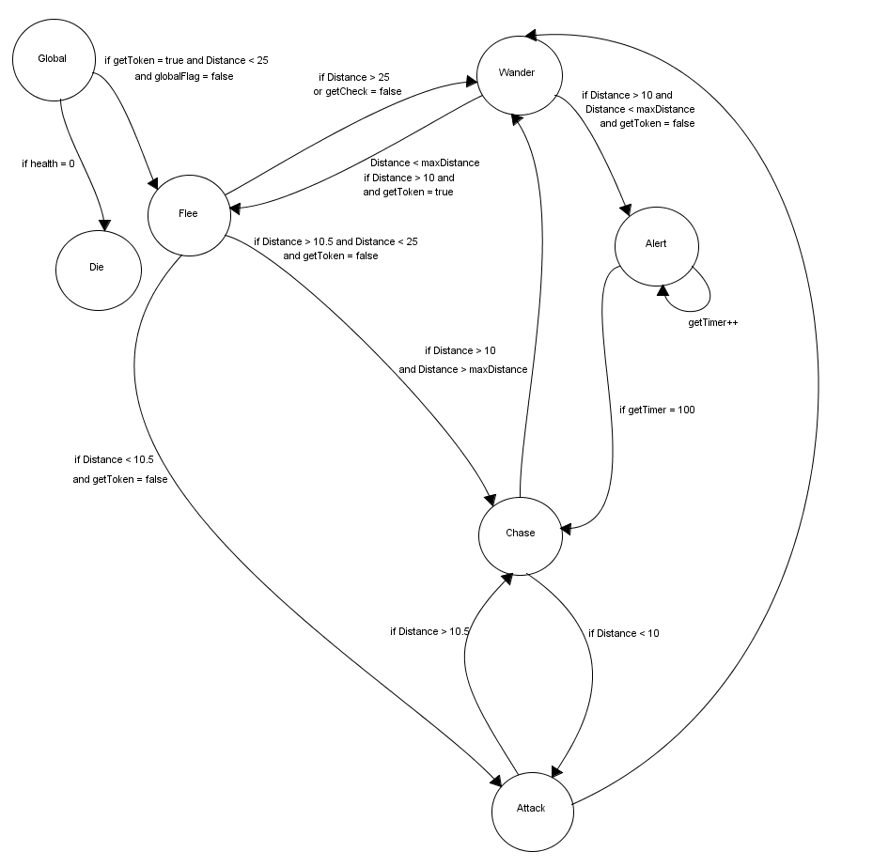

Each state has the enemy perform different actions in-game. A summary for each state is below:

### Wander State

The **Wander State** is the state that enemies will be in whenever the player is outside of their viewing distance. In this state, enemies patrol the environment by walking around a random movement path. This is achieved by projecting a circle in front of the enemy, which the enemy then moves towards and follows a target that only moves along the perimeter of the given circle. Because the enemy is not in any harm from the player in this state given the distance between themselves and the player, they utilized the walk animation in this state.

If the player gets within a distance value that is less than 10 and the player doesn’t have a Double Damage token equipped, the enemy will transition to the **Alert State**.

If the players get within a distance value that is less than 10 and the player does have a Double Damage token equipped, the enemy will transition to the **Flee State.**

If enemy health reaches 0 while in this state, the **Global State** will trigger and transition the enemy to the **Die State**.

### Alert State

The **Alert State** is the state that enemies will find themselves in when they spot the player character after previously being in their **Wander State**. The Enemy will play a pointing animation in this state, which in turn sends an alert of its position to any enemies within a certain distance via the engines messaging system. If the enemies are within distance of the alert, they will walk to the position in which the alert was made to assist the alerted enemy. At the end of the animation, the enemy will transition to the **Chase State**.

If the player happens to collect a Double Damage token while the enemy is chasing, they will transition to the **Flee State** via the **Global State**.

If enemy health reaches 0 while in this state, the **Global State** will trigger and transition the enemy to the **Die State**.

### Chase State

The **Chase State** is the state that enemies are in when the player is within view distance of them but further than 10 units away. The Enemy will utilize a running animation in this state and will attempt to chase down the player.

If the enemy chases the player down to the point where distance between them is less than 10, the enemy will transition to the **Attack State**.

If the player happens to collect a Double Damage token while the enemy is chasing, they will transition to the **Flee State** via the **Global State**.

If enemy health reaches 0 while in this state, the **Global State** will trigger and transition the enemy to the **Die State**.

### Attack State

The **Attack State** is the state that enemies are in when the distance between them and the player is less than 10. In the Attack State, the Enemy will utilize the shooting animation and fire their gun at the player character.

If the distance between the player and the enemy becomes greater than 10.5, the enemy will transition to the **Chase State**.

If the player happens to collect a Double Damage token while the enemy is chasing, they will transition to the **Flee State** via the **Global State**.

If enemy health reaches 0 while in this state, the **Global State** will trigger and transition the enemy to the **Die State**.

### Flee State

The **Flee State** is the state that enemies are in when the player has a Double Damage token and is within their view distance. The Enemy will utilize a running animation in this state and will attempt to run away from the player.

If the enemy manages to get to far away from the player to the point in which the player is further than their view distance, the enemy will transition to the **Wander State**.

If the distance between enemy and player is greater than 10.5 and less than 25 and the token has expired, the enemy will transition to the **Chase State**.

If the distance between enemy and player is less than 10.5 and the token has expired, the enemy will transition to the **Attack State**.

If enemy health reaches 0 while in this state, the **Global State** will trigger and transition the enemy to the **Die State**.

### Die State

The **Die State** is the state that enemies will enter when their health reaches zero. Once in this state, a death fall down animation will place once, which in turn leaves the enemy corpse on the floor for a few seconds before it is deleted and removed from the world. Upon deletion of the enemy, the FSM is also destroyed.

### Global State

The **Global State** is a state which manages transitions that can occur in any state. Because the **Die State** and **Flee State** can be triggered while in any other state, they are placed in the **Global State**.

All these states work together to create an intelligent enemy character.

## Animations

As mentioned in the AI Features section above, enemies make use of various animations to present themselves as more realistic entities.

Below is a summary of how each animation appears and what situations they occur:

### Walk Animation

The walk animation is used by the enemy when in their Wander State. It uses the exact same frames used in the Run Animation, but it is slowed down to resemble a walk.

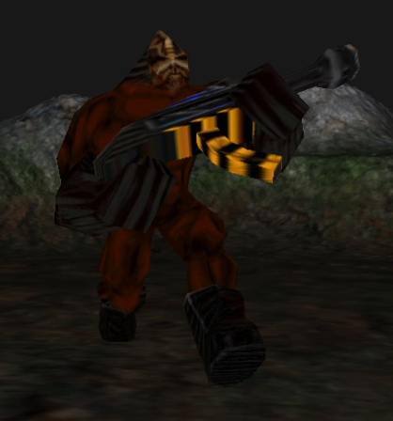

### Run Animation

The run animation is used by the enemy when in both the Chase and Flee State. When in the Chase State, the enemy will run towards the player, while in the Flee State, the enemy will turn its back to the player and run away.

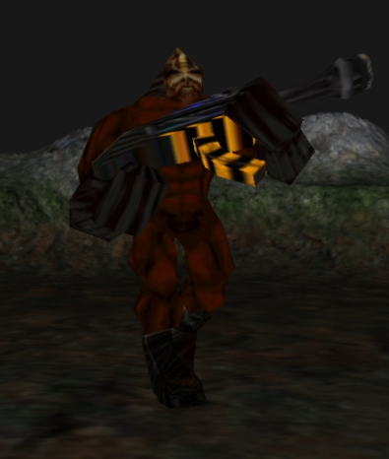

### Shooting Animation

The shooting animation is used by the enemy when in the Attack State. The animation sees the enemy fire its gun at the player.

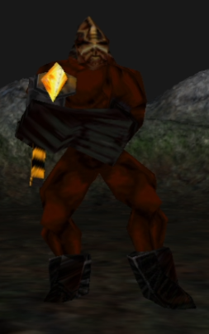

### Pointing Animation

The pointing animation is used by the enemy when in the Alert State. The animation sees the enemy point at the player, which in turn alerts nearby enemies to come to the enemy’s position to assist.

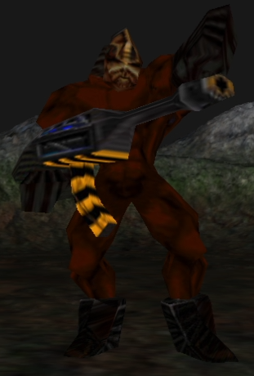

### Death Animation

The death animation is used by the enemy when in the Die State. The animation sees the enemy fall down and die.

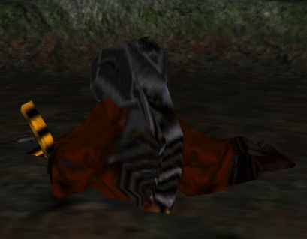

# World Editing

## Overview

There is not dedicated world editing through a dedicated world editor, however scripts provide a way for the user to change and customize aspects of the world such as the terrain, skybox, and object placement.

## World Editing Detail #1 – Customisable Terrain!

Using the terrain.lua script, you can customize aspects of the terrain such as its size, scale, textures, detail map and shaders. You can even change the heightmap used entirely, allowing you to make new maps simply by providing it a different heightmap.

## World Editing Detail #2 – Customisable Skybox!

While we think our skybox looks neat, we have provided via the skybox.lua script the ability to change the images that make up the skybox. This means that you can add in any skybox that you want by simply providing images to the paths that correspond to each skybox face.

## World Editing Detail #3 – Customisable Object Placement!

We could have just provided a concrete amount of objects and placed them at designated places on the map, but we thought it’d be nice to provide the user the freedom to place as many objects of any type that they like anywhere on the map. Through the world1.lua script you can add in any model you like into the game world and can make use of the loops to randomly place them around the map. If you prefer to place them somewhere particular each time, all you need to do is provide the positions. Granting the user this level of freedom essentially makes this script the main level editing tool.

# Extra Miscellaneous Stuff

## Overview

Just a space to explain miscellaneous stuff we are messing around with.

## Junk I am working on…